ESP32 and XIAO App Note for EVE BT817Q CFA10121 boards:

This app note provides the details necessary to use an Espressif ESP32 or Seeed Studio XIAO microprocessor board with a Crystalfontz 4.3-inch EVE module. The PCB used in the CFA800480Ex-043Sx or CFA480272Ex-043Sx modules is the CFA10121, as referenced below.
In the image below, the ESP32 land is outlined in red, the necessary hardware changes in red dashes. The XIAO land is outlined in pink, the necessary hardware changes in pink dashes. The relevant header (J3) is outlined in blue.
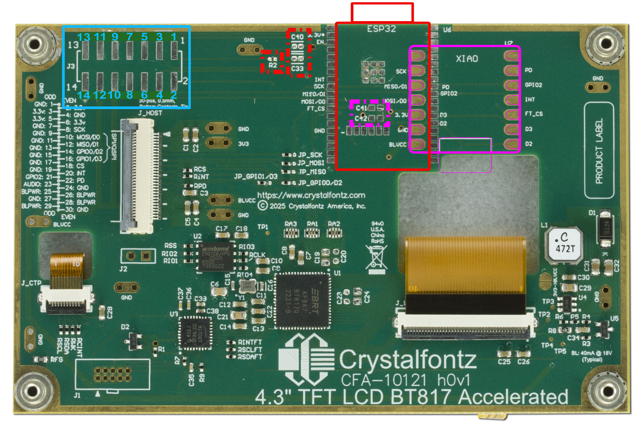

Espressif ESP32
J3 Header Table for ESP32 Pins.
Pin | Function | Description
1 | ESP_EN | Chip enable
2 | ESP_IO0 | GPIO0 determines the boot mode at startup
3 | TxD0 | Tx pin for Serial Interface
4 | RxD0 | Rx pin for Serial Interface
5 | IO22 | GPIO pin 22
6 | IO21 | GPIO pin 21
7 | IO23 | GPIO pin 23
8 | IO19 | GPIO pin 19
9 | 3V3 | 3V3 Power
10 | BLVCC | Backlight Power. Consult the display datasheet for min and max ratings.
11 | 3V3 | 3V3 Power
12 | BLVCC | Backlight Power. Consult the display datasheet for min and max ratings.
13 | GND | Ground
14 | GND | Ground

ESP32 Pinout Table – all pins not mentioned are no-connect.
Pin | ESP32 Function | CFA10121 Function | Description
1, 15, 38-39 | GND | GND | Logic and Power Ground
2 | 3V3 | 3V3 | 3V3 Power
3 | EN | EN | Enable Pin
9 | IO33 | SCK | SPI Clock
10 | IO25 | MISO/D1 | SPI MISO / Quad SPI D1
11 | IO26 | MOSI/D0 | SPI MOSI / Quad SPI D0
25 | IO0 | GPIO0/D2 | GPIO 0 / Quad SPI D2
26 | IO4 | GPIO1/D3 | GPIO 1 / Quad SPI D3
27 | IO16 | FT_CS | Chip Select
28 | IO17 | INT | Interrupt Pin
29 | IO5 | GPIO2 | GPIO 2
30 | IO18 | PD_HOST | Power Down pin from Host (reset)
31 | IO19 | IO19 | GPIO 19 on J3
33 | IO21 | IO21 | GPIO 21 on J3
34 | RXD0 | RXD0 | Serial Rx Pin on J3
35 | TXD0 | TXD0 | Serial Tx Pin on J3
36 | IO22 | IO22 | GPIO 22 on J3
37 | IO23 | IO23 | GPIO 23 on J3

Hardware Modifications for the ESP32-WROOM and ESP32-ROVER:
Populate R2 with a 10kohm pull up 0402 resistor.
Populate C33 and C40 with sufficient decoupling 0603 capacitors. A 1uF and a 0.1uF can be used.

Programming the ESP32:
The Enable, IO0 and serial pins are brought out to pins 1-4 of J3.

Standard ESP32 programming procedure at the time of this writing:
- Pull EN and IO0 to ground
- Release EN
- Release IO0
- Send firmware via UART
- Pull EN to ground and release to reset the device

For further reference, see Espressif’s documentation about programming an ESP32 device. https://docs.espressif.com/projects/esptool/en/latest/esp32/advanced-topics/boot-mode-selection.html?highlight=boot

Seeed Studio XIAO
J3 Header Table for XIAO Pins – Most pins are reserved for the ESP32.
Pin | Function | Description
1 | N/A | Used for ESP32 only
2 | N/A | Used for ESP32 only
3 | N/A | Used for ESP32 only
4 | N/A | Used for ESP32 only
5 | N/A | Used for ESP32 only
6 | N/A | Used for ESP32 only
7 | N/A | Used for ESP32 only
8 | N/A | Used for ESP32 only
9 | 3V3 | 3V3 Power
10 | BLVCC | Backlight Power. Consult the display datasheet for min and max ratings.
11 | 3V3 | 3V3 Power
12 | BLVCC | Backlight Power. Consult the display datasheet for min and max ratings.
13 | GND | Ground
14 | GND | Ground

XIAO Pinout Table
Pin | XIAO Function | CFA10121 Function | Description
0 | D0/A0/DAC | GPIO0/D2 | GPIO 0 / Quad SPI D2
1 | D1/A1 | GPIO1/D3 | GPIO 1 / Quad SPI D3
2 | D2/A2 | FT_CS | Chip Select
3 | D3/A3 | INT | Interrupt Pin
4 | D4/A4/SDA | GPIO2 | GPIO 2
5 | D5/A5/SCL | PD_HOST | Power Down pin from Host (reset)
6 | D6/A6/Tx | NC
7 | D7/A7/Rx | NC
8 | D8/A8/SCK | SCK | SPI Clock
9 | D9/A9/MISO | MISO/D1 | SPI MISO / Quad SPI D1
10 | D10/A10/MOSI | MOSI/D0 | SPI MOSI / Quad SPI D0
11 | 3V3 | 3V3 | 3V3 Power
12 | GND | GND | Ground
13 | VUSB | BLVCC | Backlight Power. Consult the display datasheet for min and max ratings.

Hardware Modifications for the XIAO Boards:
Populate C41 and C42 with sufficient decoupling 0603 capacitors. A 1uF and a 0.1uF can be used.

Programming the Xiao:
It is expected to use the USB header on a XIAO board for programming.

